Exercise 3

The task for exercise 3 was quite substantial, in my opinion. It was to create a program to generate a One-Time Pad key and then use this to encypt/decrypt text. The OTP key needed to be quite a large size (approx 1mb, though mine ends up generating a 2mb file) in order to ensure secrecy of the message. To generate the key I created a random array of bytes to the size of 1024x1024, and used the SecureRandom framework from the Java Security class to generate secure, random bytes of information (Figure 1). These bytes were then converted into hexadecimal characters and stored in a string (or put into a file). To encrypt the plaintext the program runs through the OTP key and the hexadecimal plaintext in parallel and XORs the two values at each location to give a third hex value, the ciphertext. To obtain the plaintext again, we simply XOR this ciphertext with the key to give the message, and convert that hexadecimal string into characters. This is a relatively simple program which comes down to about 4 methods and a few lines of code.
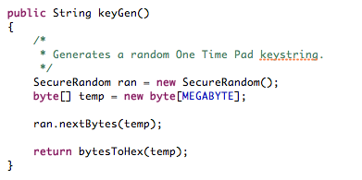Figure 1: The keygen method to create a One-time Pad encryption key.
To test whether my encrypt and decrypt functions worked I sent encrypted text and the generated key file to a couple of course mates to decrypt using their solutions, and they sent me text to decrypt as well. All of the texts sent and received were decrypted successfully.

The difficult part of this exercise was the attack on multiple-time pad ciphertexts. I know the theory behind one method of decrypting two-time pad ciphers (Which I learned both from lectures and from this website: http://travisdazell.blogspot.co.uk/2012/11/many-time-pad-attack-crib-drag.html - obtained through Google) called crib-dragging, which after conversation with some other students of the Cryptography module, is the method they used to decrypt the ciphertext. I understand this method and, whilst it is crude and inefficient, it certainly works, though I could not conceive how to program it in a way which I was happy with, so I am left with a commented out method called “attack” (Figure 2) which shows the start of trying to decrypt the texts.
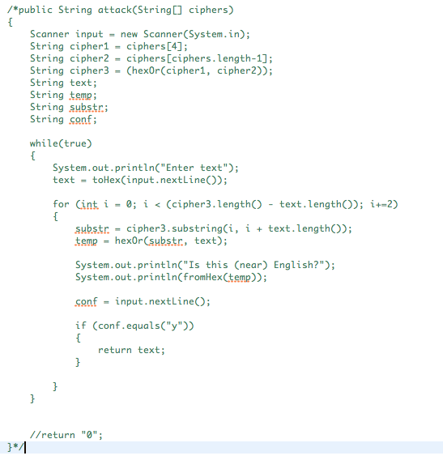Figure 2: Commented out attack method. *does not work*
Though the crib-dragging method does work, I believe that there is a more efficient method of attacking multiple-time pad usage, which becomes more effective the more each pad is used. The theory which I had is programmed (again, commented out) and called “theory” (Figure 3). The thing which I noticed when analysing the ciphertexts is that some of the hexadecimal strings are similar, which indicates that the characters at those points in the messages which are encrypted are the same. Therefore I was looking to detect where the ciphertext was similar (i.e. when the two strings were XORed, it returned “00” - the two values are the same), extending this I wanted to know when the value of the two strings was simply the inverse character (or 20h apart), as this would indicate a space character was present, due to the fact that if you XOR a lower case character with a space character you get the upper case equivalent and vice-versa. I couldn't quite figure out the logic behind using this to decrypt the whole of the text though. I was able to pull out when the two texts had similar characters, which is what the given method does, but how I could utilise that escaped me. I am a little annoyed with this, and I am very keen to know if I was actually onto something or if I was just kidding myself, so if you could let me know (either in my feedback, or via email), I would greatly appreciate that. Apologies for not providing a better description of how to crack the ciphertext.

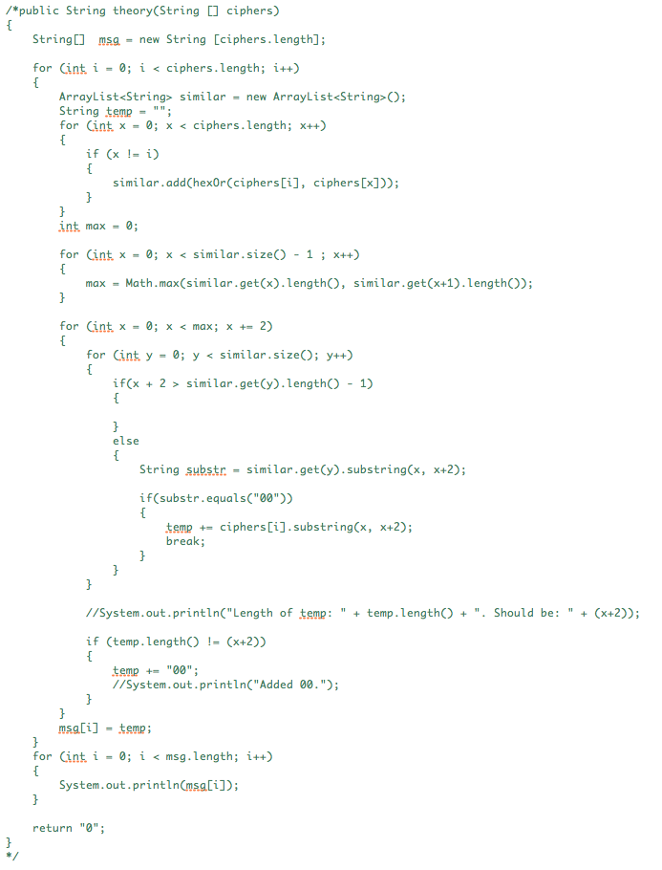Figure 3: My commented out theory method. *Incomplete*

